Homework: Confident Class Map Examples

Due: 6 points

# Section 1.2 Your preferred plot

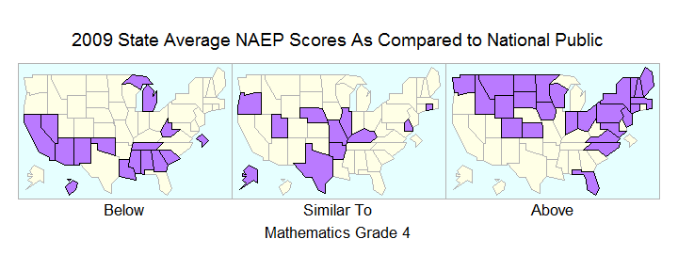

# Section 2 Plot and one more where you have select one or two of the other comparison columns in the data frame

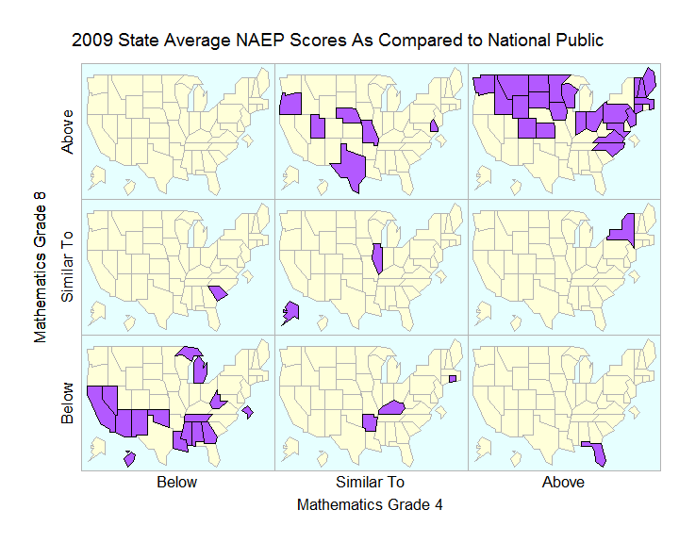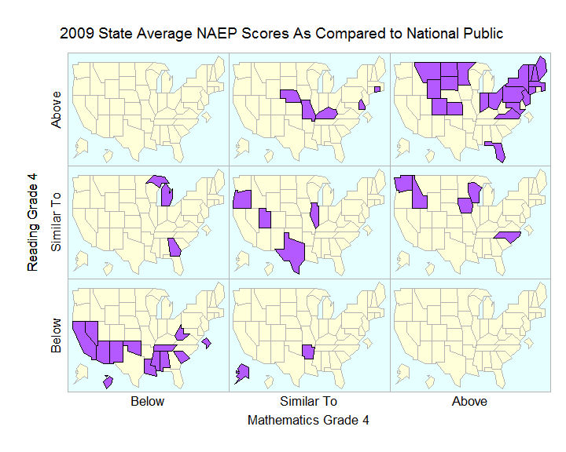

# Section 3: Preferred plot from 3, Indicate why you preferred it or if picked one but did not have a preference

I chose the second plot with the legend label on the same line as the legend colors. I think this makes it more clear, that the text is part of the label.

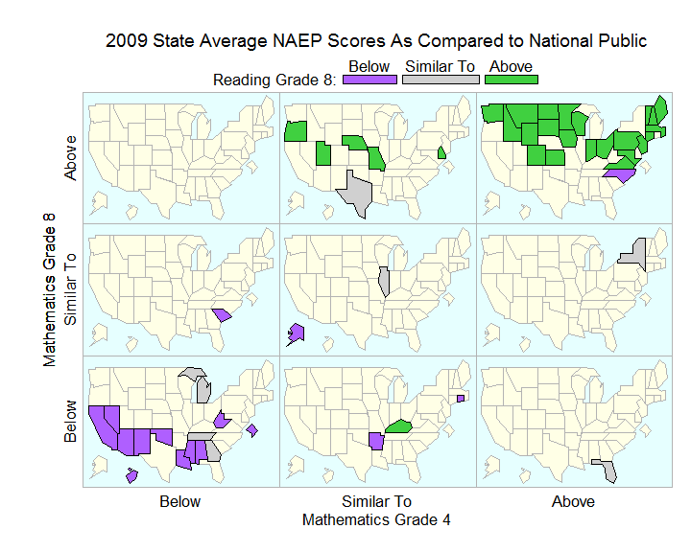

# Section 4: one plot, you choice

